I have a Little Frog

I have a little frog
His name is Tiny Tim
I put him in the bath tub
To see if he could swim
He drank up all the water
And gobbled up the soap
And when he tried to talk
He had bubbles in his throat

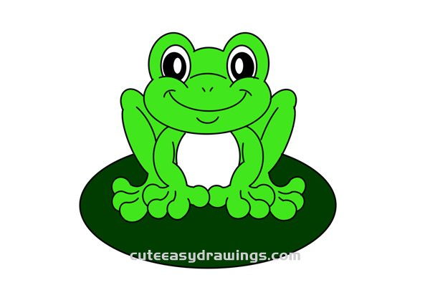

Lucky Little Leprechaun

Lucky little leprechaun
All dressed in green
Why do you hide your gold from us
And hide in sights unseen

We chase you and try and catch you
But you always run away
Maybe we could be friends
Especially on St Patrick’s Day

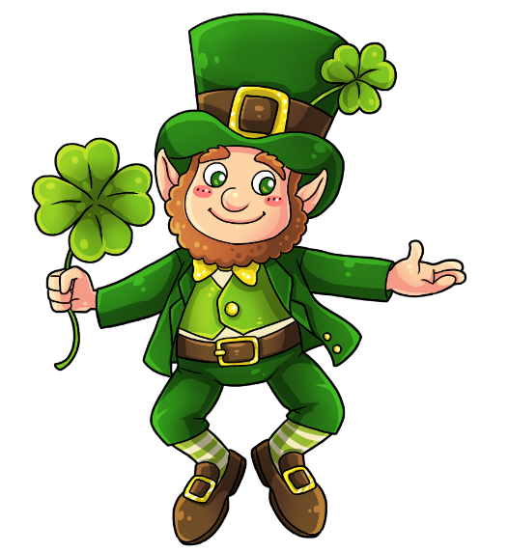

Greatheart and the Brain Drain

Comfort me with cabbages
My brian’s not screwed in tight
Help me plug my ears in case it
Wanders out of sight

With a cabbage in my left ear
And a corkscrew in my right
I forget about ontology and
And I sleep just fine at night

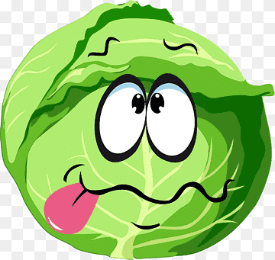

Down With Greens

I don’t like peas
I don’t like beans
I don’t like squash
Or other greens.
Instead I’d like
A cake and pie
An ice cream cone
Stacked sky high
It seems when you’re hungriest
You eat the foods
You like the best
So pass the sprinkles
If you please
And pass the pie
But keep your peas
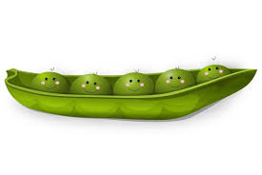
Green
Green is so important
Because we see it all around
It's up very high on the trees
And on the grass that is on the ground
Green is the colour of
The plants that grow in the south
It's also the colour of a Brussels sprout
That I refuse to put in my mouth
Green is on the traffic light
When the cars can go
All the green disappears
When it starts to snow
The most important thing about the colour green
Is because of my mother
NO she is not green
It's her favourite colour

